5.2 Polar Coordinates

Cartesian (Rectangular) Coordinates | Polar Coordinates
- Plot points by moving  - horizontally (x-direction) and  - vertically (y-direction)  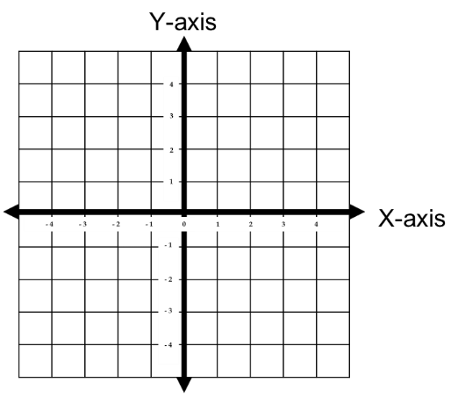  - We have coordinates | - Plot points by  - rotating by a given angle and  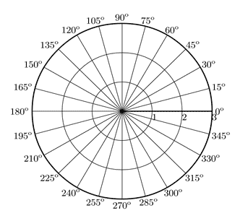  - moving a specified length  Pole  Polar Axis  - We have coordinates

Example 1: Plot the points in the polar coordinate system provided below.
  - A | - B | - C | - D

Note: There are infinitely many ways to write the coordinates of a point in polar form!!!
To form the same point with different coordinates we simply use an angle that is coterminal with .

Polar –Rectangular Conversions
Converting from polar to rectangular
$$θ$$
$$\left(x,y\right)$$
$$y$$
$$x$$
$$r$$

Converting from rectangular to polar

Example 2: Convert to rectangular coordinates.

Example 3: Convert to polar coordinates.

Converting Equations

Formulas for converting equations:

Common Techniques:
- Multiplying both sides of the equation by r.
- Squaring both sides of the equation.

Example 4: Write an equivalent rectangular equation for the polar equation: .

Example 5: Use your calculator to sketch a graph of the polar curve given by .

Example 6: Use your calculator to sketch a graph of the polar curve given by .

Example 7 (you try):
- Convert the point from polar to rectangular (Cartesian) coordinates.
- Represent the point with rectangular coordinates in terms of polar coordinates.
- Use your calculator to graph and sketch the graph your calculator produces.
- Convert the equation from polar to rectangular form.

